

**UNIVERSITY OF ASIA PACIFIC**

**Department of Computer Science & Engineering**

|  |
| --- |
| DJANGO SETUP |

**Course Title :** Visual and Web Programming-II

**Course Code :** CSE 309

**Submitted by: Submitted To: Name :** Sheikh Nafez Sadnan Ali Zafar Sadiq **Reg. No. :** 20101106 Lecturer

**Roll No. :** 106 Department of CSE

**Section :** B (2) University of Asia Pacific

**STEP-1:** *pip install Django* command for installing Django

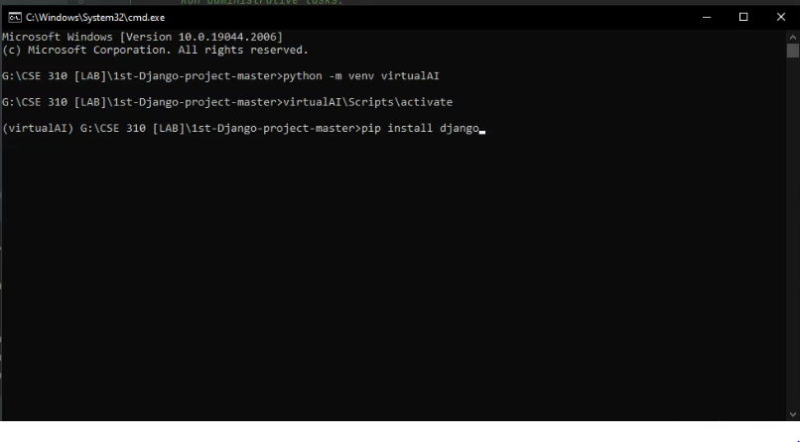

**STEP-2:** After completing installation of Django

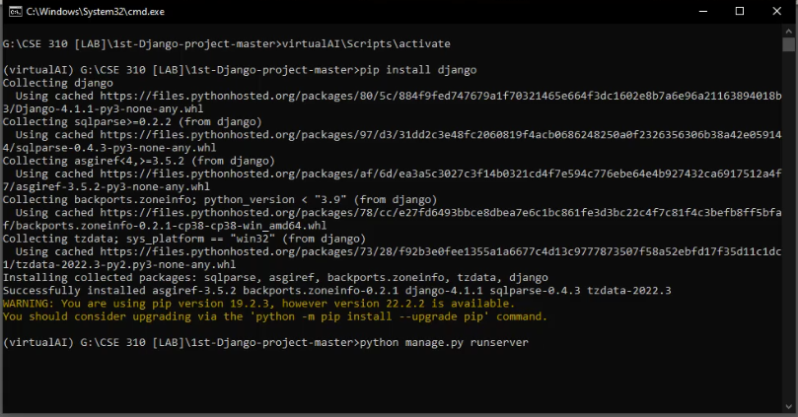

**STEP-3:** After getting the server link

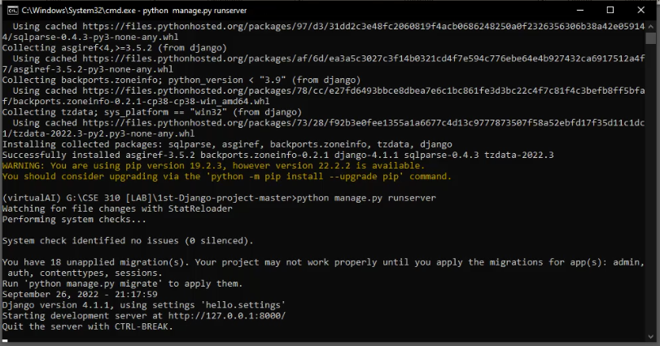

**STEP-4:** Server screen-shot

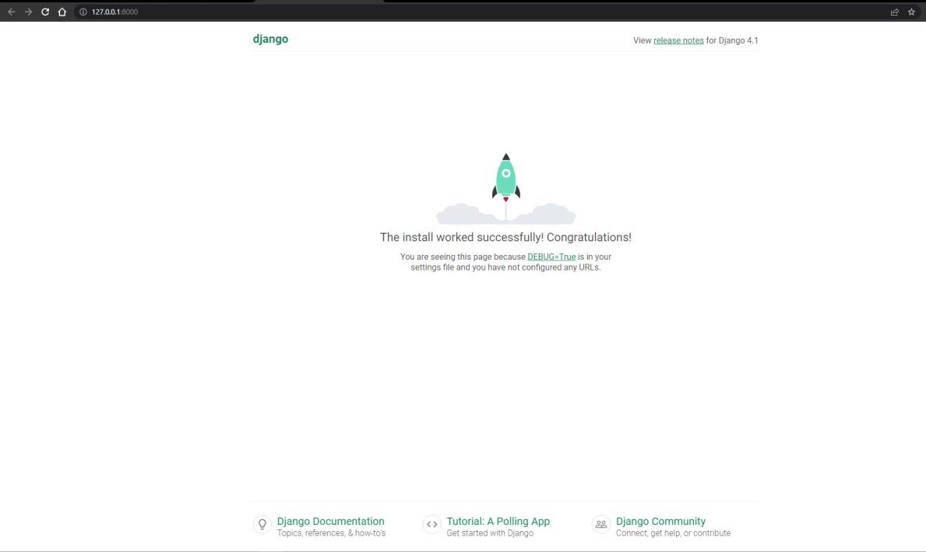

**Step-5:** URL Input

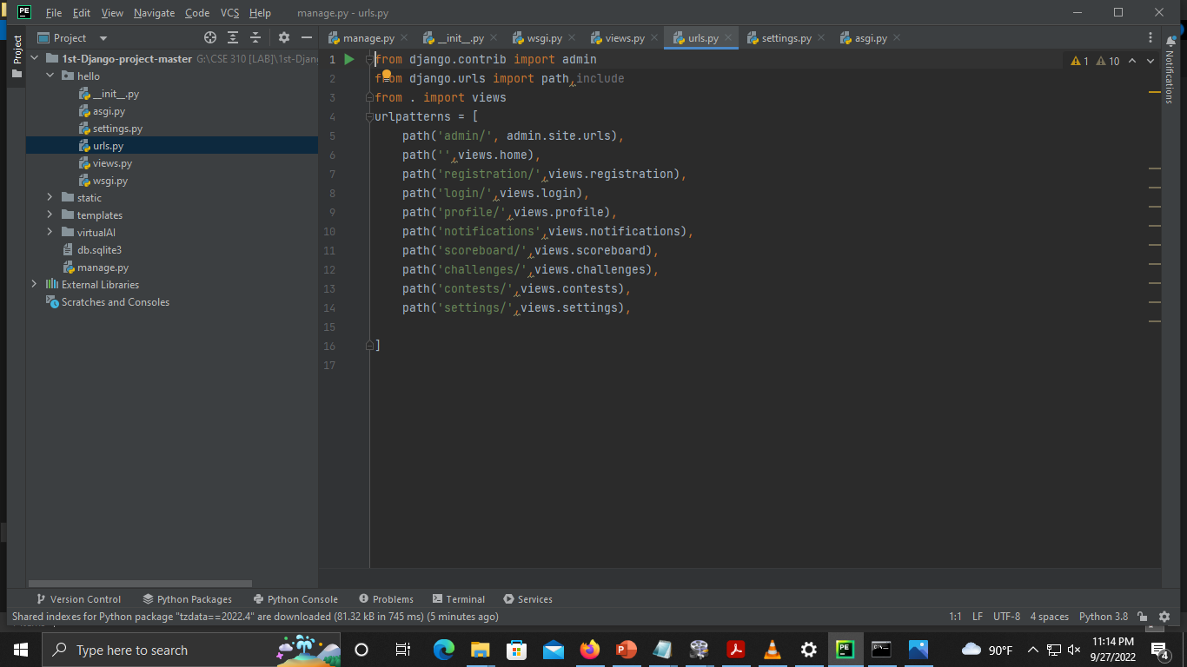

**STEP-6:** Views modification

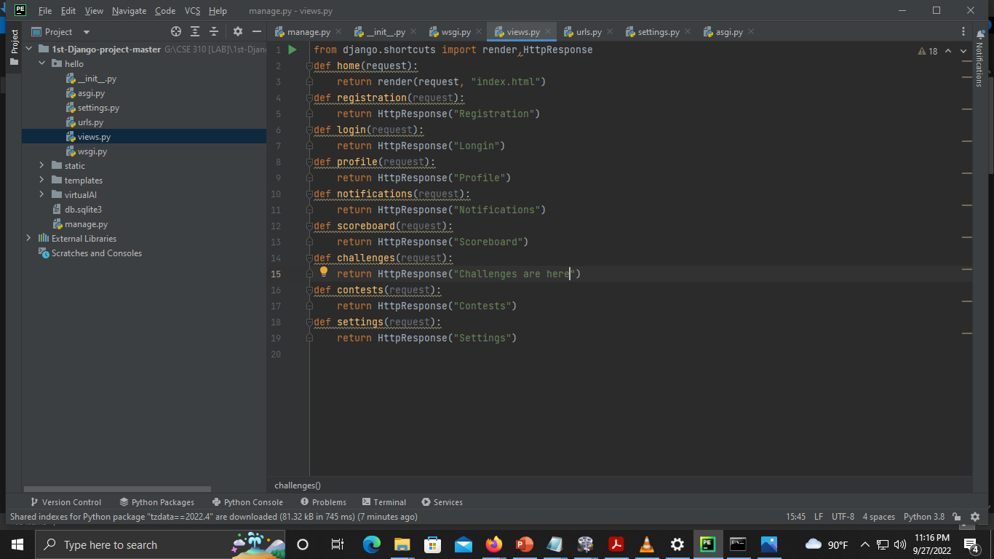

**STEP-7:** Display. Example- run the “challenges” page

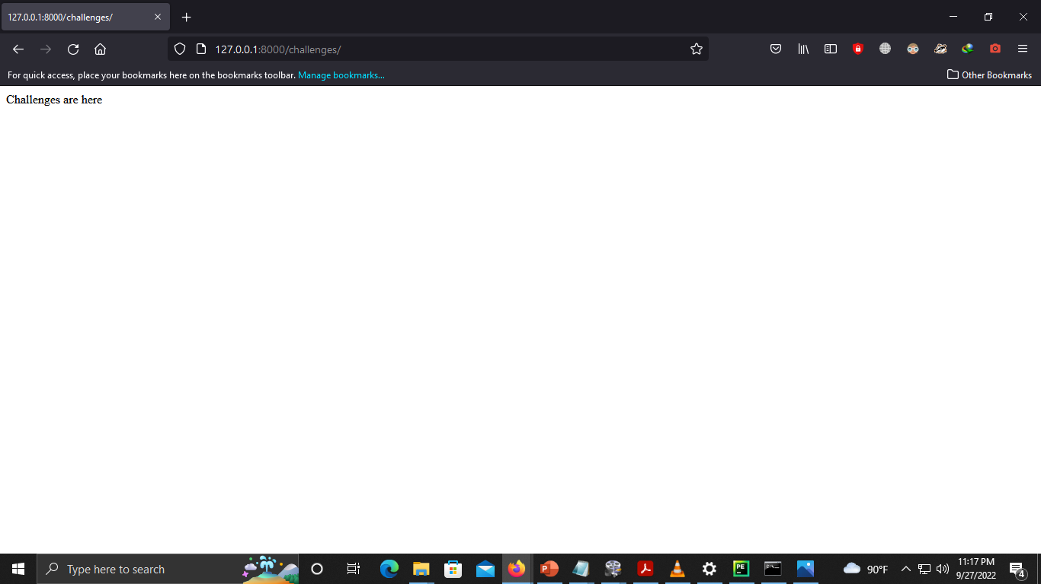

**IP Configuration** screen shot of my desktop:

